# GUJARAT TECHNOLOGICAL UNIVERSITY

Chandkheda, Ahmedabad Affiliated

Darshan Institute

of

Engineering and Technology,

Rajkot

A

Project Report On

# HOTEL INFORMATION

Under the course of

## DESIGN ENGINEERING – 1B (3140005)

B. E. II, Semester – IV

#### (Computer Engineering)

***Submitted by:***

Group:

|  |  |  |
| --- | --- | --- |
| **Sr.** | **Name of student** | **Enrolment No.** |
| 1 | YASH MENDAPARA | 180540107097 |
| 2 | MIHIR PANARA | 180540107112 |
| 3 | BHARGAV GADHIYA | 180540107051 |
| 4 | DHRUV GADHIYA | 180540107052 |

#### Prof. Firoz Sherasiya

(Faculty Guide)

#### Dr. Gopi Sanghani

Head of the Department

#### Academic year

(2019-20)

# GUJARAT TECHNOLOGICAL UNIVERSITY

Chandkheda, Ahmadabad Affiliated

Darshan Institute of Engineering & Technology, Rajkot

**CERTIFICATE**

This is to certify that the students namely, **Mr. YASH MADARIYA (180540107097), MIHIR PANARA (180540107112) ,BHARGAV GADHIYA (180540107051), DHRUV GADHIYA(180540107052)** of ***B. E. II (Computer Engineering) Semester IV*** have successfully completed the course work and related tasks for the course of **Design Engineering 1B(3140005)** during the academic term ending in the month of March 2020.

Date:

Place:

#### DR. GOPI SANGHANI

(Faculty Guide) Head of the Department

**(External Examiner)**

**Contents**

1. Introduction 4
   1. Team profile page 4
   2. Team building exercise – balloon tower 5
2. Canvas Work 6
   1. A-E-I-O-U frame work 6
   2. Mind chart 10
   3. Empathy Mapping Canvas 12
   4. Ideation Canvas 13
   5. Product Development Canvas 15
   6. Product Prototype Canvas 16
3. Log-book records 17

### Team profile page

### 

### Know yourself:

* Who are the team members?

1. YASH MADARIYA
2. MIHIR PANARA
3. BHARGAV GADHIYA
4. DHRUV GADHIYA

Provide brief intro of all team members along with guiding faculty. Have you given any fancy name

* Your team

1. Yash Madariya

* Yash Madariya is a student from computer engineering department from Darshan collage Rajkot He is our group leader for D.E .Project .He patiently works with group members and he listen everyone opinion of the team. He has ability to manage the Team . His work for de project is worthwhile & appreciable .

1. Mihir Panara

* Mihir Panara is a student from computer engineering department from Darshan collage Rajkot .He has helped us in completing sheets in de .His sincerity about project is Appreciable

1. Bhargav Gadhiya

* Bhargav Gadhiya is a student from computer engineering department from Darshan collage Rajkot .he helped us in many ways in our de project .He visited many hotel to know about the problems which they are facing now days and how we can solve it .with our de project .his work for de project is worthwhile & appreciable .

1. Dhruv Gadhiya

* Dhruv Gadhiya is a student from computer engineering department from Darshan collage Rajkot. He has helped in gathering all the information for our project. He has good knowledge about hotel .He has also helped us in completing sheets in de .his sincerity about project is Appreciable.

1. Prof. Firoz Serasiya

* Prof.Firoz Serasiya is our guide faculty from Darshan collage Rajkot .he works in computer engineering Department in our collage. He is one of best experienced faculty from our collage . He is always happy to help & guide the students for projects .his guidelines are very helpful and worth.His polite and positive attitude towards students is really appreciable. His contribution at each level of this project is worthwhile.

### Team building exercise

Build:

* How your group was formed?

We are from same collage and we all are friends. Yash has knowledge about this hotel management project so he came towards us and give us the idea that we can work on hotel management and we found that the idea is sound’s quite good . so we accepted his proposal to make project on this topic .

* Did you know anyone in your group before?

Yes , we are friends .we all are in the same class in 1st year.

* How the domain area (Project for….) was selected / thought & discussed up on?

The domain was selected by Yash. he is basically from a rajkot , so he has to travel alto to reach home in vacation , and he faced many problems during the traveling so he has given us that the idea we can work on bus hotel management and solve the current problems which people face during traveling.

* Prepare a brief note about Observation(Canvas) technique you have used. Include the ‘Lemon-case’

### A-E-I-O-U framework

### Discuss about each of you’re A-E-I-O-U task perform.

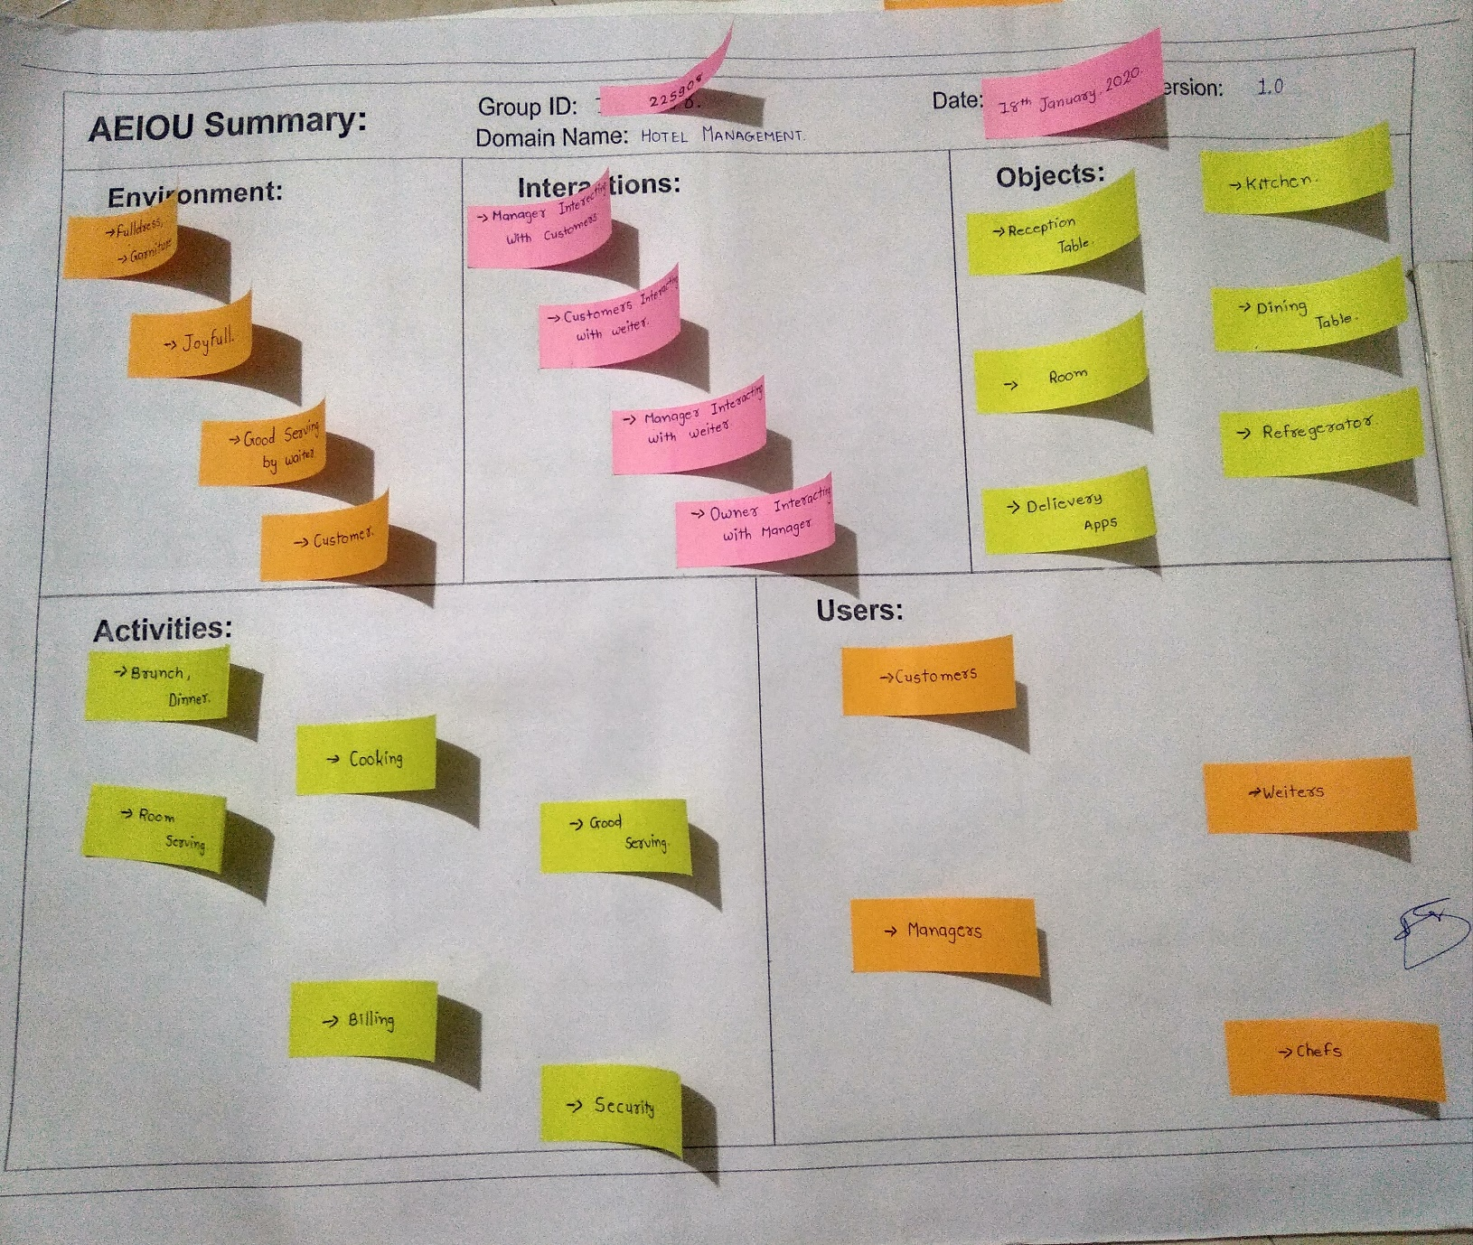

***Figure 2.1 A-E-I-O-U Framework***

2.2 Mind chart

* Mind mapping: from bus station you can do this kind of things like :

1. Food & Beverage
   1. restaurants
   2. room services
   3. conferencing and banqueting
2. Front Office
   1. Reservation or cashier
   2. agent
   3. night auditor
3. Back Office
   1. Finance management
   2. guest information archive
4. Concierge
   1. Hotel porter
   2. security

1. Maintance
   1. House keeping
   2. laundry
2. Room Division
   1. amenities
   2. accommodation
   3. ententainment

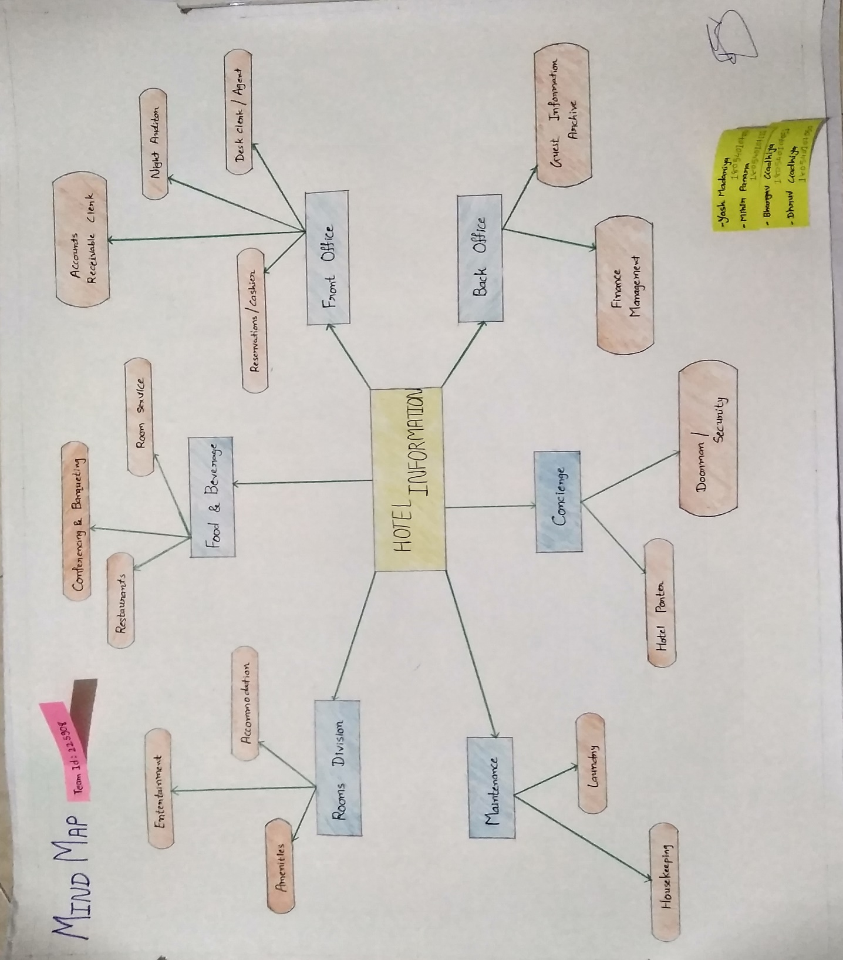

### 2.3 Empathy Mapping Canvas

* Include an image (or parts of images) and discuss about Empathy mapping

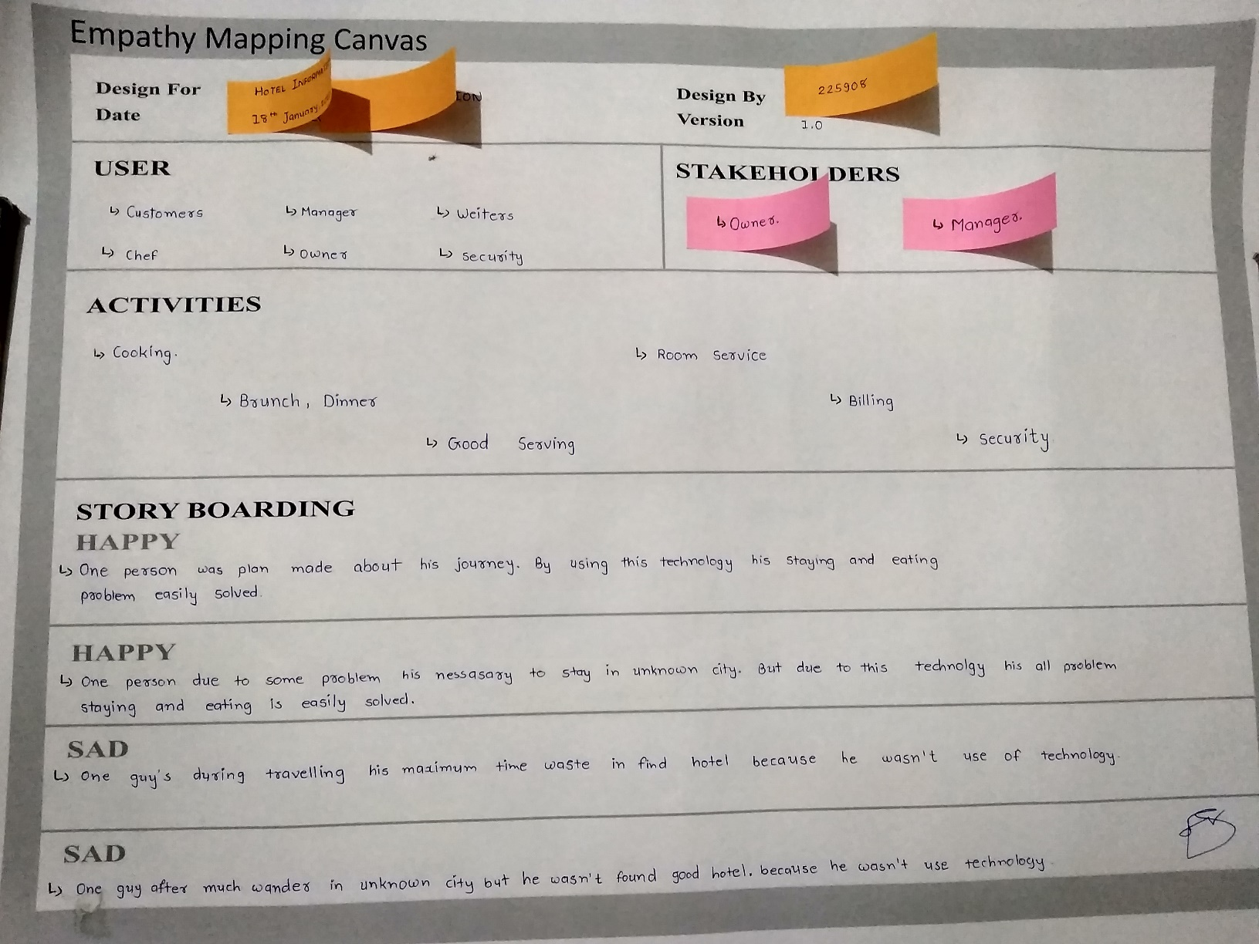

***Figure 2.2.1 Empathy Canvas work***

* Who were the stakeholders? What make you feel to include these activities on canvas? You may mention each one.
* Stakeholders:

1. Owner or

2. manager

* What activities are mentioned? What make you feel to include these activities?

You may mention each one.

* Activities:
  + - 1. Brunch, Dinner
      2. Cooking
      3. Room service
      4. Billing

* Can you describe the stories here in brief, about the happenings and feelings of the user for which the stories have been framed?
* during travelling or tour to stay unknown place customer facing some problems like find hotel and most is time wasting.

### 

### 2.4 Ideation Canvas

* Include an image (or parts of images) and discuss about Ideation process you have done in group; Enlist people identified;

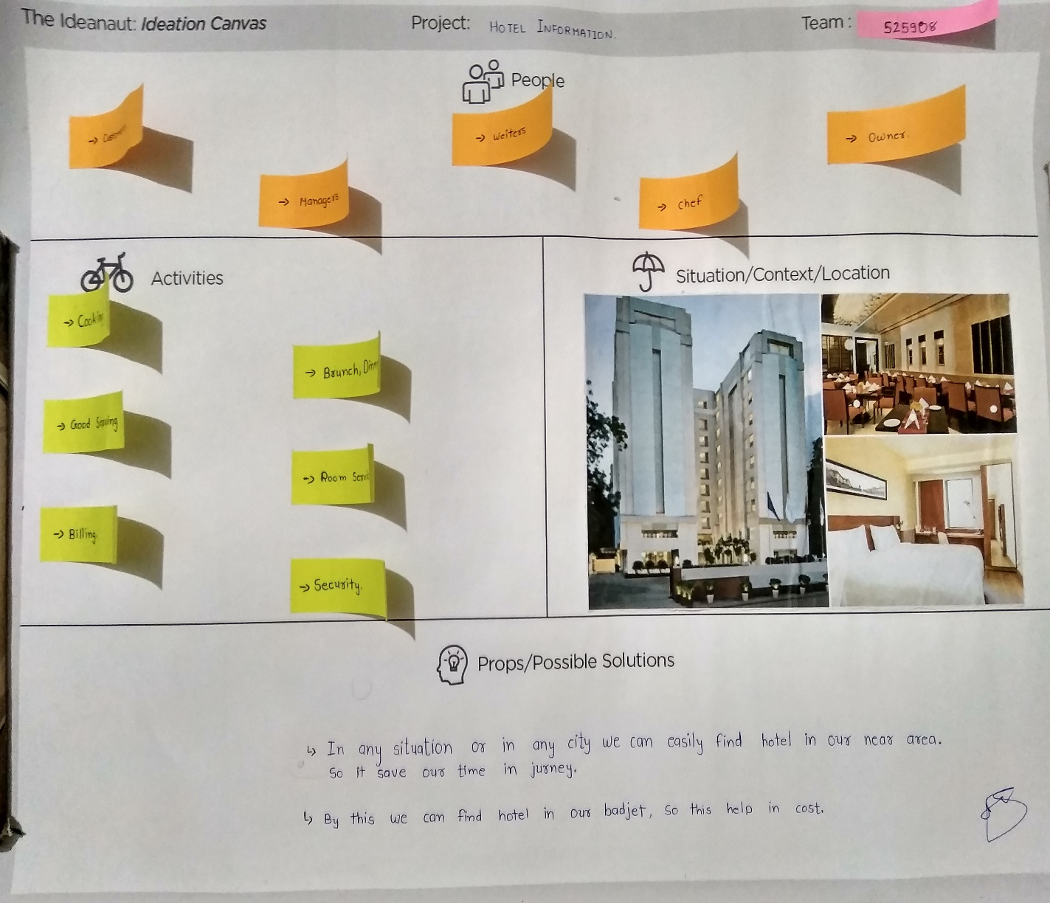

***Figure 2.4 Ideation Canvas work***

* Who were the stakeholders? What make you feel to include these activities on canvas? You may mention each one.
* Stakeholders:

1. Owner

2. manager

* What activities are mentioned? What make you feel to include these activities?

You may mention each one.

* Activities:

1. Brunch, Dinner

2. Cooking

3. Room service

4. Billing

* Can you describe the stories here in brief, about the happenings and feelings of the user for which the stories have been framed?
* during travelling or tour to stay unknown place customer facing some problems like find hotel and most is time wasting.

### 2.5 Product Development Canvas

* Include an image (or parts of images) and discuss about Product Development Canvas you have done in grou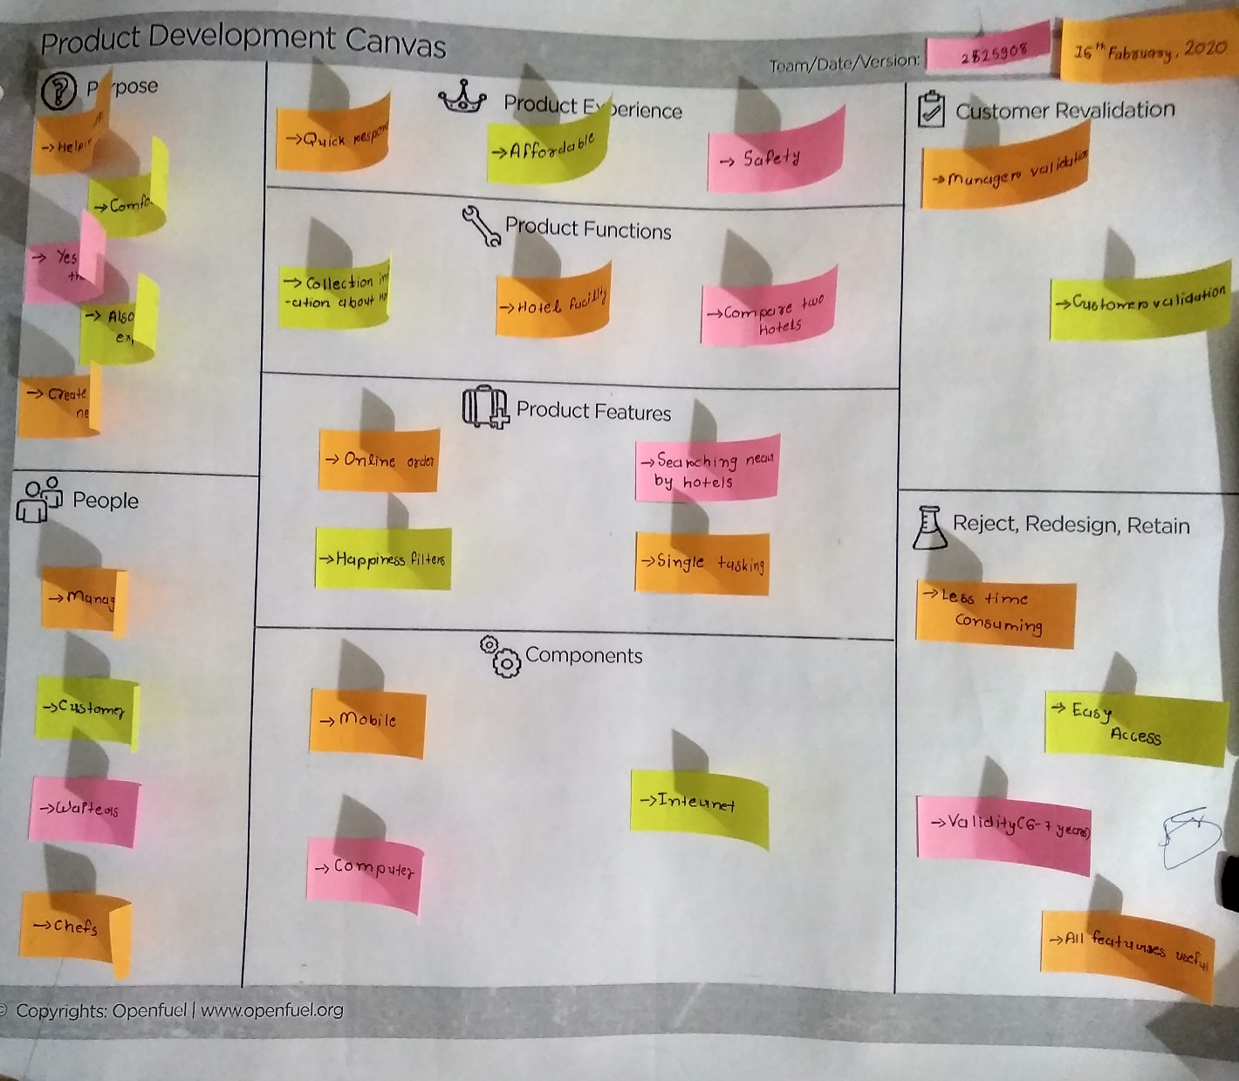

***Figure 2.5.1 Product Development Canvas work***

* Describe about each section of PDC
* What is important input received while carrying out revalidation process? Discuss.
  + - 1. Purpose : In PDC we have purpose of our topic, product experience, product functions, product features , components ,people which are relevant with our topic.
      2. People : manager, customer, waiter,chefs
      3. Components : Mobile, Computer, Internet
      4. Customer revalidation : Manager validation, Customer Validation, Security.
      5. Product experience :Quick Information, Affordable, Safty.

### 

### 2.5 Prototype Canvas

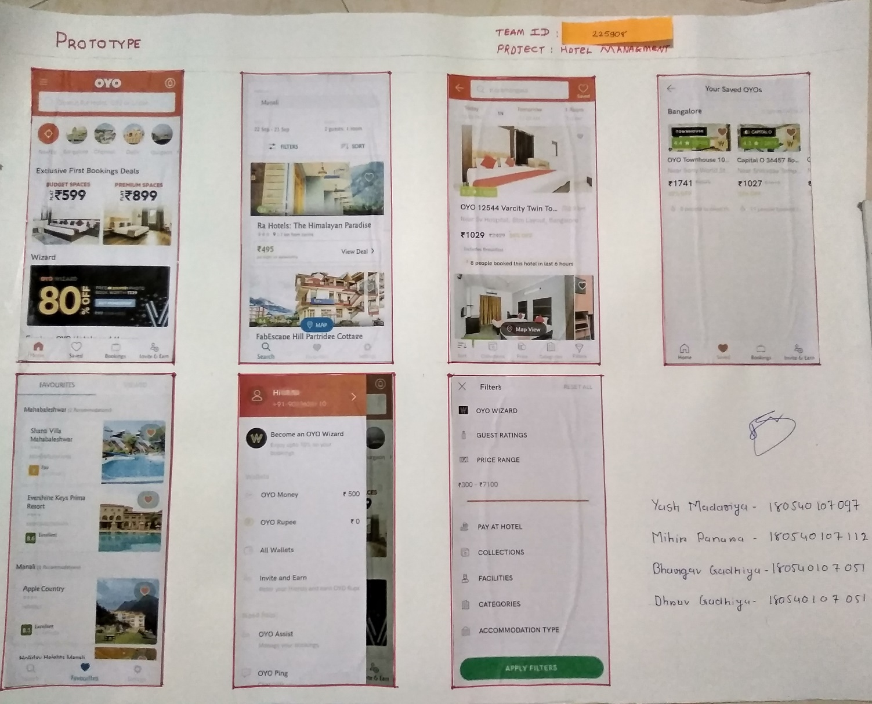

***Figure 2.6.1 Project Prototype Canvas work***

Include copy of individual log-book records as an attachment of previously signed pages here.

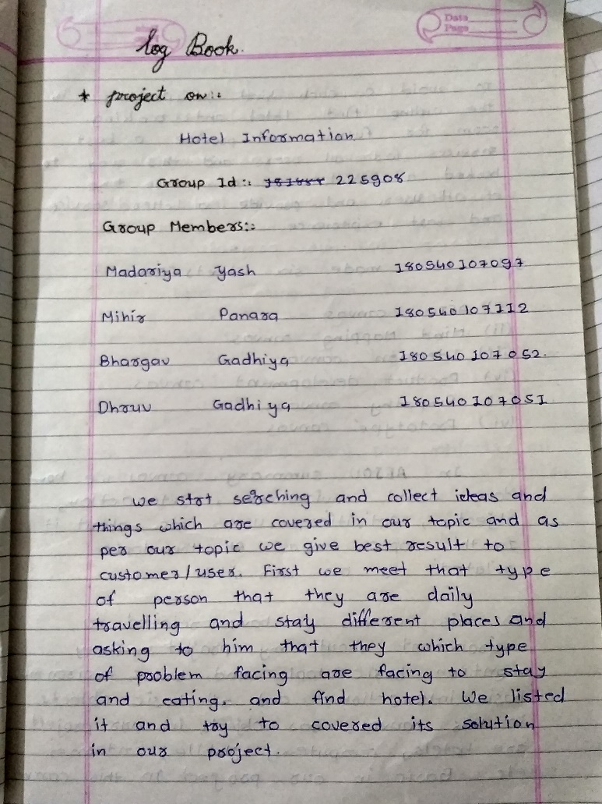

***Figure 3.1 log-Book frame works***

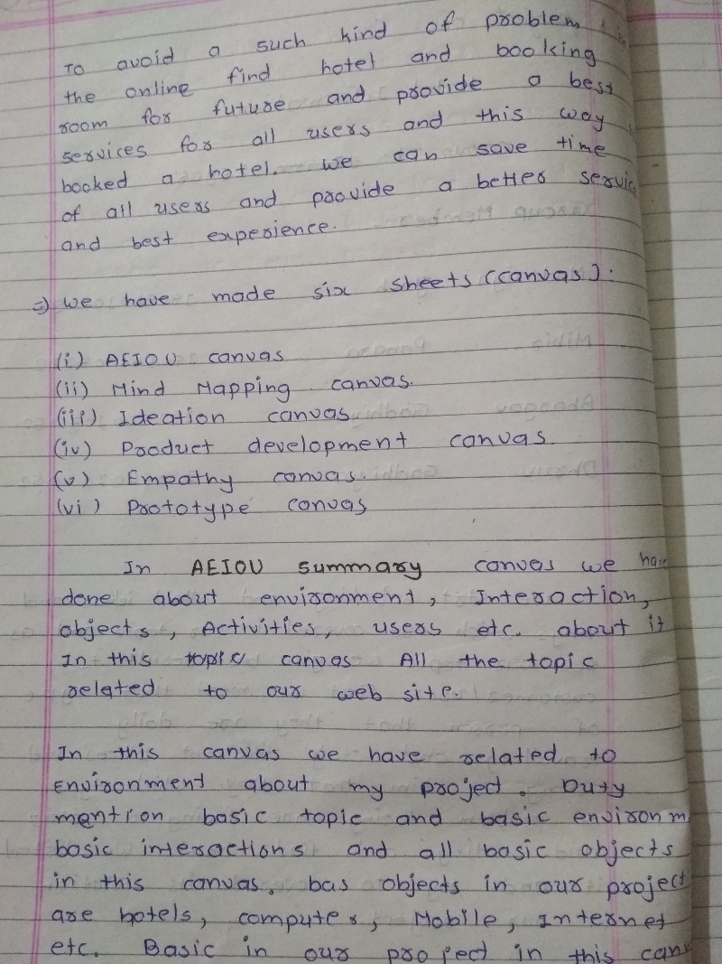 2.

***Figure 3.2 log-Book frame works***

3.

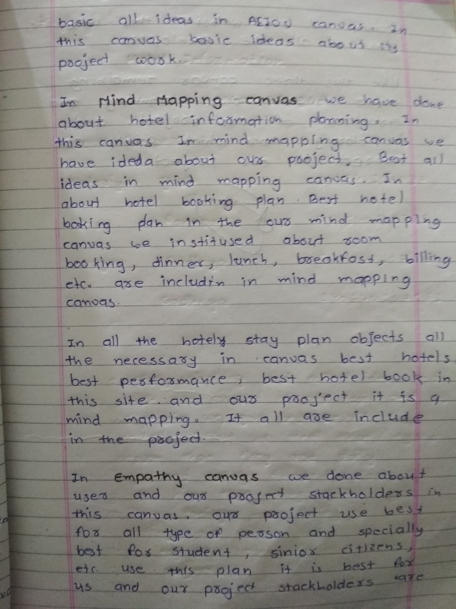

***Figure 3.3 log-Book frame works***

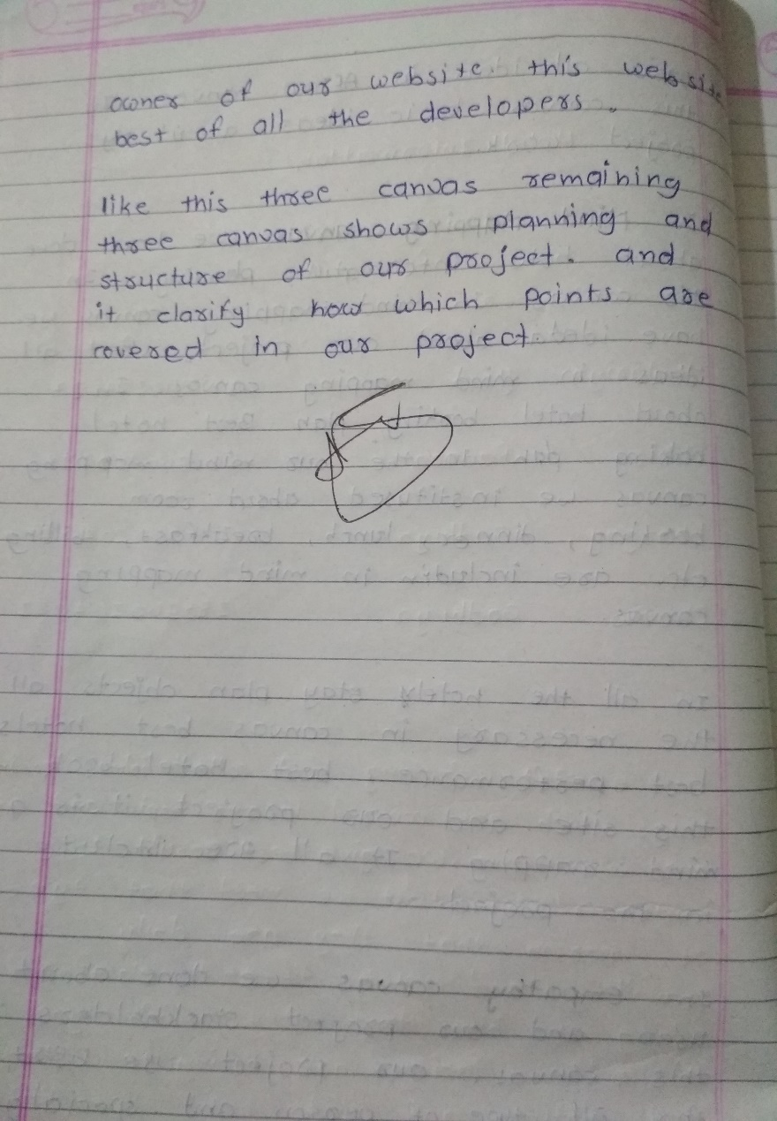4.

***Figure 3.4 log-Book frame works***